JEED Manuscript Template
This JEED manuscript template is for use by authors of all article types. Please read all guidance in this document, listed below and as comments, prior to starting your manuscript.

Best Practices for Manuscript Composition
JEED uses the Council of Science Editors (CSE) Name-Year citation style. Familiarize yourself with this style and its requirements prior to starting your manuscript. If your manuscript is suitable for publication but it does not adhere to CSE Name-Year citation style, you will need to make the necessary changes prior to acceptance.

This template is intended for use only with Microsoft Word. Please keep this in mind if you intend to use this template with other software. Opening or saving this file in Google Docs, or exporting it as a Word file from Google docs, may result in formatting changes or loss of the guidance included in the comments. Similar problems can result when converting text from PDF or LaTeX files, then inserting it into this template.

Submitting a clean document file will help your manuscript reach an editor more quickly and will make reviewers’ jobs easier. Pay close attention to these items when composing your manuscript in Microsoft Word:

- Do not delete, alter, or replace the pre-formatted heading and body text styles in this template.
- Turn off Word’s automatic numbering feature. Number sections manually.
- Leave the line number feature turned on.
- Use Times New Roman as the font for all text.
- Do not use the tab key to indent paragraphs or align text.
- Do not hit return at the end of lines unless you are ending a paragraph.
- Do not add extra lines between paragraphs or sections.
- Compose equations and tables using Word’s built-in tools.
- Insert figures as low-resolution images. If your paper is deemed suitable for publication, you will be asked to provide high-resolution (300 dpi) images. Keep this in mind when creating your original images.
- If a section does not apply to your paper, delete it from the template.

You are responsible for correcting any formatting issues caused by importing/exporting or file collaboration prior to submission. We are unable to consider papers with formatting issues until the problems are resolved.

Read the JEED Author Guidelines and Submission Information for full details.

When your manuscript is complete, delete this introductory text, delete all comment threads, resolve/turn off any tracked changes, and rename this file prior to submission. Visit the JEED Submission page to start your submission.

Article Type
JEED-I: Insights in Ecological Engineering (~3,000 words).
Targeted research and science communication focused on compelling insights in the field. Authors of Insights articles may use the headings and subheads recommended below or more generic headings depending upon the topic and approach. Please use a small number of infographics, photos, or other visual materials as appropriate.
Research Paper (~6,000 words).
Article of original hypothesis-driven research based on new data collection, data analysis, or modeling.
Subject-Area Review (~10,000 words).
In-depth, systematic review of the literature on a specific ecological engineering design-related topic. We particularly welcome systematic reviews on ecological engineering topics that follow a transparent and repeatable approach to identifying, selecting, and synthesizing evidence (e.g., as outlined in the PRISMA 2020 guidelines).
Research Case Study (~6,000 words).
Focused examination of a particular case or design innovation within a real-world context, typically assessing before and after implementation of an ecological engineering design or process.
Design Research Portfolio (~1,000 words plus graphics).
Presentation of original research with a visual emphasis on the design approach, process, and results. Consideration should be given as to how material can be presented in both HTML and printable PDF formats. To submit a Design Research Portfolio in a nontraditional layout, please contact the Managing and Production Editor for guidance. Guidelines in this template are suggestions for organizing the submission; authors may add and/or remove sections or subheads as they wish. All sections should be developed using both text and graphics.
Editorials, book reviews, and commentaries.
Contact the Editor in Chief if interested in submission.

Article Title
[text]

Authors
Author’s full name
Author’s affiliation
Author’s mailing address
Author’s ORCID iD formatted as XXXX-XXXX-XXXX-XXXX

Correspondence
Corresponding author’s full name
Corresponding author’s email address

Highlight
[text]

Keywords
[text]

Abstract
[text]

Graphical Abstract (optional)
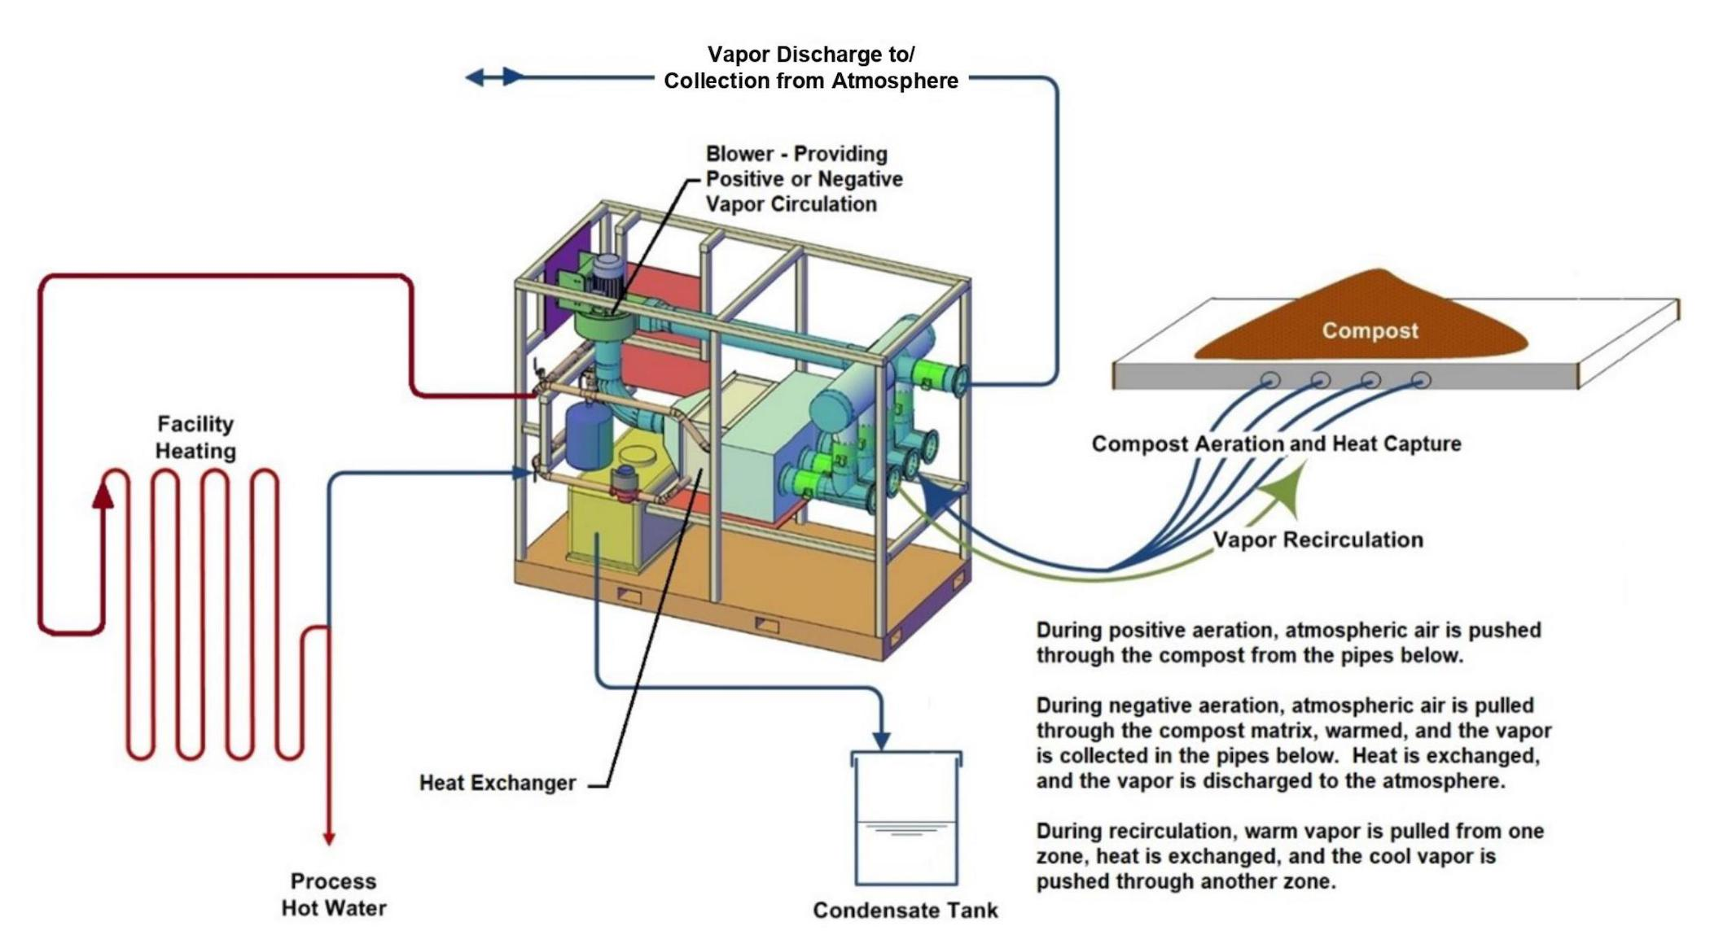
Graphical abstract. Type your caption directly beneath the image. If an image has been previously published, include an in-text citation and be prepared to provide a written copyright release.

Study/Project Photographs (optional)
Study/Project Photographs. Type your caption directly beneath the image. Credit the photographer or source. If an image has been previously published, include an in-text citation and be prepared to provide a written copyright release.

1. Introduction
[text]

2. Materials and Methods
[text]

2.1. Case Study Site
[text]

2.2. First-level Subhead
[text]

2.2.1. Second-level Subhead
[text]

3. Results
[text]

3.1 First-level Subhead
[text]

3.1.1. Second-level Subhead
[text]

4. Discussion
[text]

4.1 First-level Subhead
[text]

4.1.1. Second-level Subhead
[text]

5. Conclusion
[text]

Figures
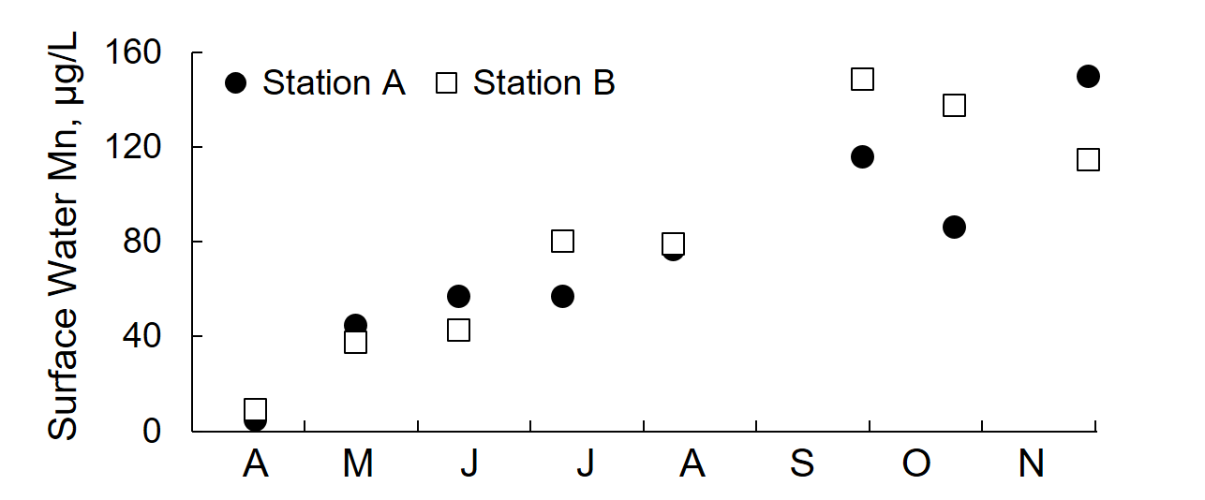
Fig. X. Place the figure caption directly below the figure.

Tables
Table X Table title in sentence case
Heading | Heading  (units) | Heading  (units) | Heading  (units) | Heading  (units)
Text | xxx.xx | xxx.xx | xxx.xx | xxx.xx
Text | xxx.xx | xxx.xx | xxx.xx | xxx.xx
Text | xxx.xx | xxx.xx | xxx.xx | xxx.xx
Text | xxx.xx | xxx.xx | xxx.xx | xxx.xx
Text | xxx.xx | xxx.xx | xxx.xx | xxx.xx
Text | xxx.xx | xxx.xx | xxx.xx | xxx.xx
Text | xxx.xx | xxx.xx | xxx.xx | xxx.xx
Text | xxx.xx | xxx.xx | xxx.xx | xxx.xx
Notes: Add notes directly beneath the table if needed.

Supplementary Material
The online version of this article contains a link to a downloadable supplementary material file, which includes Text S1: Description, Figure S1: Title, Table S1: Title.

Acknowledgments
[text]

Author Contributions Statement
Conceptualization: XX; data analysis: XX, YY, ZZ; data curation: XX; formal analysis: XX, YY; funding acquisition: XX, YY; investigation: XX, YY, ZZ; laboratory analyses: XX; methodology: XX, YY; project administration: XX; resources: XX; software: YY; supervision: XX; validation: XX, YY, ZZ; visualization: ZZ; writing–original draft: XX; writing–review & editing: XX, YY, ZZ. All authors have read and agreed to the published version of the manuscript.

Conflict of Interest Statement
The authors have no conflict of interest to report.

Data Availability Statement
[text]

Related Publication Statement
Earlier drafts of sections of this manuscript are included in the MS Thesis of the lead author at the University of Vermont, as well as in conference proceedings related to a poster presentation.
Citations:
Bondeson, FA. 2023. Technological and spatial analysis techniques to improve outcomes of agricultural nutrient management [thesis]. Burlington (VT): University of Vermont. 138 p. https://scholarworks.uvm.edu/graddis/1682/
Stoermann M, Bondeson F, Faulkner J, Roy E. 2022. Evaluation of agricultural nutrient management technologies at Vermont Natural Ag Products, Middlebury, Vermont. Waste to Worth; 2022 April 18–22; Oregon, OH [accessed 2023 Oct 26]. Available from: https://lpelc.org/evaluation-of-agricultural-nutrient-management-technoloies-a-vermont/

References
[text]

